Curriculum Vitae (C.V.)
- Personal data:
Name (Arabic) | حنان حسن صبري البدرى
Name (English) | Hanan Hassan Sabry
Department | Dermatology , Venereology and Andrology
College | Benha Faculty of medicine.
Academic degree | professor and head of Dermatology,Venereology and Andrology Department
Office Address | Benha
Mobile 1 | 01013910001
Email (university) | HANAN.ALBADRY@fmed.bu.edu.eg
Email (alternative) | Hanansabry20032003@yahoo.com
- ORCID iD
https://orcid.org/0000-0003-3933-2064

- Citations =350
- h. index = 10
- i10 index =10

Recent Photo (passport format) | 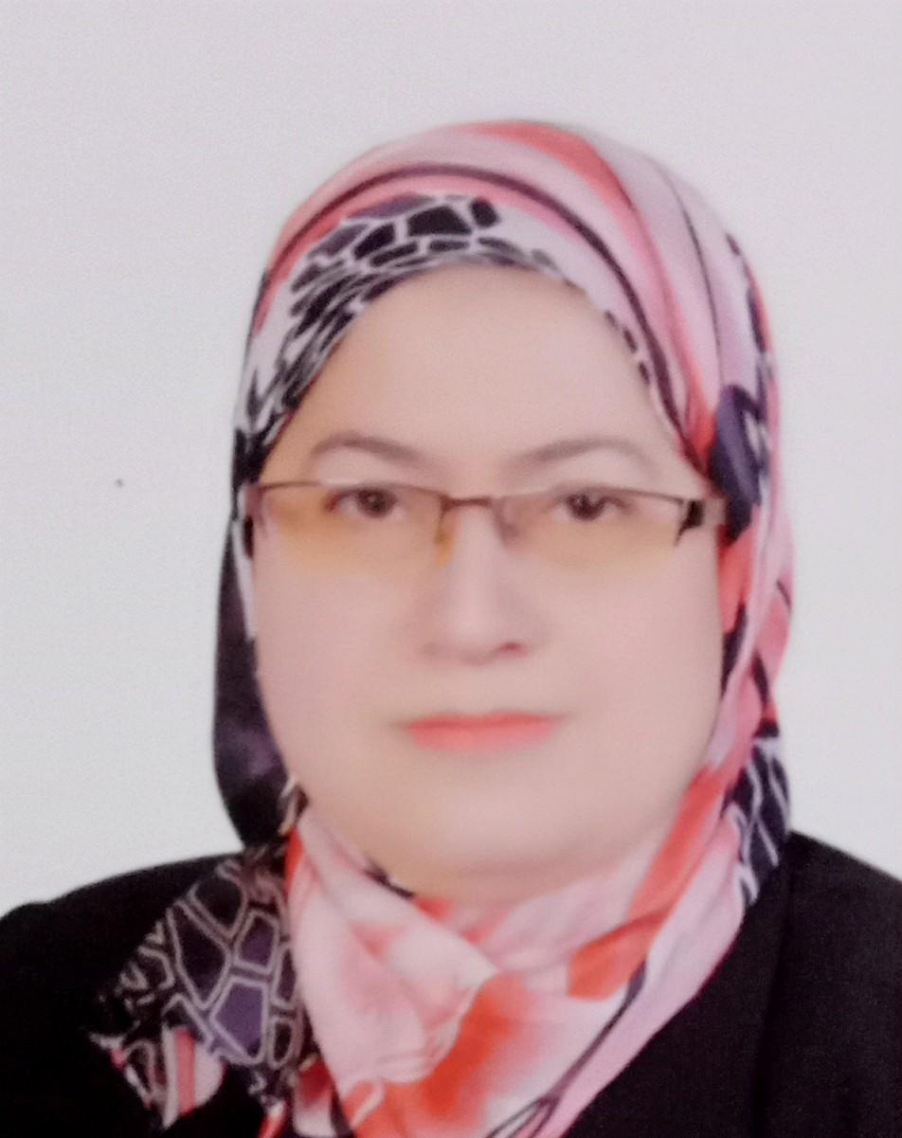

- Education
2.A.Degree obtained;
Institution | Degree obtained | Year
Benha faculty of medicine | M.D | 2000
Benha faculty of medicine | M.Sc. | 1994
Benha faculty of medicine | M.B.B.Ch. | 1988

2.B.Specialty;
General specialty. | Dermatology , Venereology and Andrology
Specific specialty. | Dermatology , Venereology and Andrology

- C.Language skills (Excellent, Very Good, Good or Basic);
Language | Reading | Speaking | Writing
Arabic. | Excellent. | Excellent. | Excellent.
English. | Excellent. | Very good | Very good
French. | Basic | Basic | Basic
Other (specify).

- Membership of institute (List):
- The Egyptian Society of Dermatology and Venereology.
- The Egyptian Women's Dermatologic Society.

- Distinction and Awards (List): Participating in the faculty development and quality project as a quality coordinator of the Derm 600 master's program.
- Academic:
6.A. Teaching; For each course taught,
  - Give one separate file: course description, 2 samples of assignments, 2 samples of exams, 2 samples of model answers.
  - Give the URL of the course web site, if any.
  - Provide power point slides (available).
6.B. Courses at under graduate level;
L Lectures | Clinical rounds
- Basics and orientation  - Fungal skin infections  - Mycobacterial skin infections  - Allergic skin diseases | .
6.C. Courses at post graduate level;
Lectures  e | Clinical rounds
B 1. Basics and orientation
2. Immunobullous diseases
3. Genobullous diseases.
4. Mycobacterial infections
5. Nail disorders
6. Skin tumors

- PhD/M.Sc Supervision in the last 3 years:
Title | PhD/M.Sc | Year completed
- Evaluation of SerumAlanine Level in Alopecia Areata Patients | M.Sc | 2019
- Polymorphism of TIMP-2 Gene in Patients with acne vulgaris | M.Sc | 2019
- Polymorphism of Matrix Metalloproteinase 2 in patients with acne vulgaris | M.Sc | 2019
- Evaluation of Denim Alanine level in Patients with Acne Vulgaris | M.Sc | 2019
- Serum level of brain derived neurotropic factor in patients with pityriasis rosea | M.Sc | 2019
- Comparison between dermoscopic and histopathological features of keloids and hypertrophic scars before and after different treatment modalties | M.Sc | 2019
- Epidemiological study of leprosy in Egypt [ 2010 2015] | M.Sc | 2019
- Evaluation of skin diseases in psychiatric patient and addicts | M.Sc | 2019
- The efficiency of combined plasma gel and fractional co2 laser in treatment of atrophic acne scars | M.Sc | 2019
- Serum level of galectin 3 in patients with infantile haemangioma | M.Sc | 2019
- Fractional co2 laser assested delivery of topical tranexamic acidverus glutathione in treatment of melasma | M.Sc | 2019
- Comparison of Q switched 1064 nm Nd : YAG laser and fractional co2 laser efficiencies in treatment of atrophic fascial post acne scars | M.Sc | 2020
- Compairing efficacy and safety of low level light therapy , mesotherapy and prp in ttt of different types of alopecia | PhD | 2019
- Association between microRNA 196a-2polymorphosm and serum tyrosinase level and its influence on ttt of vitiligo patients | PhD | 2019
- Efficacy of combined fractional co2 laser with verapamil hydrochloride or 5 flurouracil in treatment of hypertrophic scars and keloids | M.Sc | 2017
- Serum and seminal tumour necrosis factor alpha correlation with semen quality in obese and non obese patient with varicocele in Qualiobia government | M.Sc | 2017
- Dermoscopic feature of some inflammatory dermatoses | M.Sc | 2017

- Committees ( List ):
- The Student Affairs Committee, Faculty of Medicine, Benha (2020- till now).
- Research ethics committee , Benha faculty of medicine (2009- till now).

- The Board of Benha Faculty Medicine (2015 - 2016; 2020- till now).
- The Graduate Studies Committee, Benha faculty of medicine (2014-2015)
- Member of the Cultural Relations Committee, Benha faculty of medicine (2017-2018).
- Areas of research:
www. Pubmed .com
www.tandfonline.com/
www.weily.com
https://ijdvl.com/
http://wolterskluwer.com/
https://www.dovepress.com/index.php

- List of Publications: (Authors, Title, Journal/Conference name, pages from to, year, link to full paper):
- Factors affecting vitiligo response to treatment: do MiRNA 196a2C/T gene polymorphism and serum tyrosinase levels have any role?
Monib KME, Sabry HH, Hussein MS, El-Fallah AA, Salem RM.J Dermatolog Treat. 2020 Aug 24:1-5. doi: 10.1080/09546634.2020.1810202. Online ahead of print.PMID: 32838589

- Assessment of laser-assisted delivery vs intralesional injection of botulinum toxin A in treatment of hypertrophic scars and keloids.
Sabry HH, Ibrahim EA, Hamed AM.Dermatol Ther. 2020 Jul 8:e13980. doi: 10.1111/dth.13980. Online ahead of print.PMID: 32638463

- Topical kinase inhibitors induce regression of cutaneous squamous cell carcinoma.
Yang X, Daifallah AEM, Shankar S, Beer J, Marshall C, Dentchev T, Seykora F, D'Armas S, Hahn J, Lee V, Sabry HH, Farag AM, Seykora JT.Exp Dermatol. 2019 May;28(5):609-613. doi: 10.1111/exd.13902. Epub 2019 Mar 13.PMID: 30762245

- The Efficacy of Combining Fractional Carbon Dioxide Laser With Verapamil Hydrochloride or 5-Fluorouracil in the Treatment of Hypertrophic Scars and Keloids: A Clinical and Immunohistochemical Study.
Sabry HH, Abdel Rahman SH, Hussein MS, Sanad RR, Abd El Azez TA.Dermatol Surg. 2019 Apr;45(4):536-546. doi: 10.1097/DSS.0000000000001726.PMID: 30829753.

- Endothelial dysfunction marker YKL-40 is elevated in male patients with idiopathic infertility.
Hanafy SM, Sabry HH, Sabry JH, Hamed AM.Andrologia. 2018 Feb 2. doi: 10.1111/and.12988. Online ahead of print.PMID: 29392759

- Peripheral blood toll-like receptor 4 correlates response to candida immunotherapy of warts.
Sabry HH, Hamed AM, Salem RM, Marei AM, El Sebaey RM.Dermatol Ther. 2018 Sep;31(5):e12691. doi: 10.1111/dth.12691. Epub 2018 Sep 18.PMID: 3022601

- Independent of DAZL-T54A variant and AZF microdeletion in a sample of Egyptian patients with idiopathic non-obstructed azoospermia.
Shafae MME, Sabry JH, Behiry EG, Sabry HH, Salim MA, Fayez AG.Appl Clin Genet. 2018 Jul 19;11:81-87. doi: 10.2147/TACG.S158297. eCollection 2018.PMID: 30050315

- Clinimetric analysis of recently applied quantitative tools in evaluation of vitiligo treatment.
Mikhael NW, Sabry HH, El-Refaey AM, Salem RM, El-Gendy MF, Farid SA.Indian J Dermatol Venereol Leprol. 2019 Sep-Oct;85(5):466-474. doi: 10.4103/ijdvl.IJDVL_63_17.PMID: 30729924

- Serum markers for asymptomatic atherosclerosis in Egyptian psoriatic patients: study controlled by Doppler estimation of carotid intima-media thickness.
Sabry HH, Sabry JH, Daifalla AEH, Akl EM, Hamed AM, Torky AAA.Vasc Health Risk Manag. 2018 Jul 9;14:145-152. doi: 10.2147/VHRM.S164274. eCollection 2018.PMID: 30022835
- Intralesional injection of bevacizumab versus triamcinolone acetonide in infantile hemangioma.
Sabry HH, Sorour NE, Akl EM.J Dermatolog Treat. 2020 May;31(3):279-284. doi: 10.1080/09546634.2019.1590521. Epub 2019 Mar 18.PMID: 30835573

- The impact of coexisting sperm DNA fragmentation and seminal oxidative stress on the outcome of varicocelectomy in infertile patients: A prospective controlled study.
Abdelbaki SA, Sabry JH, Al-Adl AM, Sabry HH.Arab J Urol. 2017 Apr 7;15(2):131-139. doi: 10.1016/j.aju.2017.03.002. eCollection 2017 Jun.PMID: 29071142

- Evaluation of biomarkers of oxidant–antioxidant balance in patients with acne vulgaris. Menha A. Ibrahima, Manal E. Helmyb, Hanan H. Sabrya, Suzan M. Faroukc,
Lubna Y. Ebrahimc and Eman R. Amer

- Apoptotic markers in spongiotic dermatitis. Khaled M. Monib, Hanan H. Sabry, Osama H. Abdel-Salam, Thomas Andl, Hany Abd Elaziz, and Taghreed Abd ELaziz. Journal of the Egyptian women′s dermatologic society September 2014 - Volume 11 – No. 3: 201-207.

- Comparative study between intralesional injection of bleomycin and 5-fluorouracil in the treatment of keloids and hypertrophic scars. Ahmed M. Kabel , Hanan H. Sabry, Neveen E. Sorour, Fatma M. Moharm. Journal of Dermatology & Dermatologic Surgery 20 (2016) 32–38.

- YKL-40: An Emerging Biomarker of Endothelial Dysfunction in Arteriogenic Erectile Dysfunction. Hanan H. Sabry, Ahmed H. Hamed, Jehan H. Sabry2, Osama H. Abdel-Salama. Human andrology, ISSN: 2090-6048, September 2017, Vol. 7, No. 3

- Evaluation of Serum Anti-Ceramide Antibody Levels in Egyptian Leprosy Patients. HH Sabry, AA Saleh, JH Sabry‏. Med J Cairo Univ 2014, 82: 395-399.

- Serum levels of homocysteine, vitamin B12, and folic acid in vitiligo. Hanan H. Sabrya , Jehan H. Sabryb , Hala M. Hashimc. Egyptian Journal of Dermatology and Venereology 2014, 34:65–69.

Vascular endothelial growth factor and subclinical atherosclerosis by carotid ultrasonography in Egyptian patients with Behcet’s disease. Sahar S. Ganeb a, *, Hanan H. Sabry b , Mohammed M. El-Assal c , Howyda M. Kamal d , Ayser A. Fayed e , Islam M. El-Shazly f. The Egyptian Rheumatologist Volume 35, Issue 2, April 2013, Pages 87-94. https://doi.org/10.1016/j.ejr.2012.12.001.

- Vitamin D levels in patients with Behcet’s disease: Significance and impact on disease measures. Sahar S Ganeb a, *, Hanan H. Sabry b , Mohammed M. El-Assal c , Howyda M. Kamal d , Ayser A. Fayed e. The Egyptian Rheumatologist Volume 35, Issue 3, July 2013, Pages 151-157. http://dx.doi.org/10.1016/j.ejr.2013.01.006.

- Attended and active participation in workshops, symposiums, and conferences:

Name of Workshops, Symposiums, and Conferences | Year
- Workshop in Research Ethics, Sunday February 24th .2008.Benha faculty of medicine, Benha University, Egypt, in collaboration with University of Maryland, School of Medicine, USA.  - The 5th Annual meeting of the Department of Dermatology and Andrology , Faculty of Medicine, Benha University, 10th – 12th may 2007.  - The 25th Annual Congress of the Egyptian Society of Dermatology and Venereology, 27th – 30th January 2009.  - The 7th Annual meeting of the Department of Dermatology and Andrology, Faculty of Medicine, Benha University 7th – 9th may 2009.  - The 4th Annual Conference and Workshops of the Afro-Asian Society for Cosmetic Dermatology and Laser. 5th - 6th May, 2010.  - Practical Esthetic Anti-Aging Course of Egypt (PEACE). 25th – 26th January 2011.  - Practical Esthetic Anti-Aging Course of Egypt (PEACE). 4th – 5th January 2012.  - The 5th Annual Conference and Workshops of the Afro-Asian Society for Cosmetic Dermatology and Laser. 11th - 12th April, 2012.  - The 8th Annual meeting of the Department of Dermatology and Andrology, Faculty of Medicine, Benha University 7th – 9th may 2012.  - The Egyptian Women's Dermatologic Society. 19th – 24th December, 2012.  - The Arab – European academy of Dermatology and Venereology in association with the Egyptian Society of Dermatology and Venereology and the Egyptian Hair Research society. 17th- 19th January 2013  - The Annual Summer meeting of the Egyptian Society of Dermatology and Venereology, 13th – 15th June 2013.  - Practical Esthetic Anti-Aging Course of Egypt (PEACE). 8th – 9th January 2014.  - The 31st Annual Conference of the Egyptian Society of Dermatology and Venereology, 5th – 6th February 2014.  - The 23rd international annual conference of The Egyptian Women's Dermatologic Society 3 – 4 December 2014.  - The 17th Annual meeting of Delta Dermatology and Venereology Association, Mansoura, 26 February 2015.  - The 11th Annual meeting of the Department of Dermatology and Andrology, Faculty of Medicine, Benha University 14th – 15th may 2015.  - The American association of continuing medical education. Educational activity (Mesotherapy & PRP- Filler - Botox- Laser) workshop. May, 14th 2015.  - The Egyptian Society of Dermatology and Venereology, 23-24 July 2015.  - The 24th international annual conference of The Egyptian Women's Dermatologic Society 9th-10th December 2015.  - Practical Esthetic Anti-Aging Course of Egypt (PEACE). 13th – 14th January 2016.  - The 9th international Annual Conference and Workshops of the Afro-Asian Society for Cosmetic Dermatology and Laser. 27th - 28th April, 2016.  - The 12th Annual meeting of the Department of Dermatology and Andrology, Faculty of Medicine, Benha University 19th – 21st may 2016.  - The American association of continuing medical education. The Int'1 Conference for Dermatology and Cosmetology- Sharm Derma , 7 May 2016.  - The Egyptian society of aesthetic dermatology. Trichoscopy Course. Sharm Derma 3rd – 6th may 2016.  - The Egyptian Society of Dermatology and Venereology in association with the international Dermoscopy Society. 17th-20th August 2016.  - The American association of continuing medical education. The Int'1 Conference for Dermatology and Cosmetology- Sharm Derma , 27th – 30th October 2016.  - The 10th international annual conference and workshop of Afro-Asian Socity for Cosmetic Dermatology and Laser. April 2017  - The 13th Annual meeting of the Department of Dermatology and Andrology, Faculty of Medicine, Benha University 18th may 2017.  - The 15th Annual meeting of the Department of Dermatology and Andrology, Faculty of Medicine, Benha University july, 2019.  - Sharm Derma Conference Part II (fall). October, 2019.  - The 8th Aannual Medical Conference of Benha Faculty of Medicine.November 2019  - ICC 2020. 1-3 October | 2008  2007  2009  2009  2010  2011  2012  2012  2012  2012  2013  2013  2014  2014  2014  2015  2015  2015  2015  2015  2016  2016  2016  2016  2016  2016  2017  2017  2019  2019  2019  2020

- Books published:
Dermatology and andrology for undergraduates (Department Book)
Chapter: Allergic skin diseases
- Positions:
 | Date | Organization | Country | Position
1 | 1990-1994 | Benha university hospital | Egypt, Benha | Resident.
2 | 1994-2000 | Benha faculty of Medicine | Egypt, Benha | Assistant lecturer.
3 | 2000-2007 | Benha faculty of Medicine | Egypt, Benha | Lecturer.
4 | 2007-2017 | Benha faculty of Medicine | Egypt, Benha | Assistant professor
5 | 2018 till now | Benha faculty of Medicine | Egypt, Benha | Professor
6 | 2020-till now | Benha faculty of Medicine | Egypt, Benha | Head of Dermatology, Venereology and Andrology Department
14 . Activities in faculty/university/community service:
Name of Activity service | Year
- Teaching (Rounds and lectures). | 2000-2021
- Clinical meeting. | 2007- 2021
- Making conferences. | 2000-2021
- Participating in the faculty development and quality project

15. Additional information :
1. And participate in the examinations (member of the tripartite committee) to set and supervise examinations for postgraduate studies of the subject matter.
2. Participating in periodic scientific meetings and scientific and clinical symposiums held in the department.
3. Attending the outpatient clinics and following up on the internal department patients.
4. Participation in establishing a scientific library in the department.
5. participating in establishing the laser treatment unit and the dermoscope unit in the department and working with them.
6. Participation in seminars to teach practical skills to students
7. Participated in the administrative and organizational preparations for the annual department conference.
8. Participation in the scientific committee to prepare for the scientific side of the annual conferences.
10. Participating in the faculty development and quality project as a quality coordinator and rapporteur of the Derm 600 master's program.
11. Giving presentations within the activities of the annual conference of the
Department of Dermatology and Venereology in Banha Medicine, entitled e.g :
- Fact or fiction : botox , fillers 2008
- Dermoscopy : hair and scalp disorders 2012
- Clues to diagnosis in dermatology 2013
- Clichés, Confusing Terms & Synonyms
- Basic trichoscopy 2016
- What is New in pigmentary disorders? 2017
- International publishing 2019
- Trichoscopy tips 2019
- Hypertrophic Scars and keloids: Current Treatments and Future Directions.

